## **Setting Up a Power BI Development Environment**

**Setup Time**: 60 minutes

**Lab Folder**: C:\Student\Modules\01_GettingStarted\Lab

**Overview**: You will begin this lab by downloading the student files for this workshop and then by following step-by-step instructions to create a new Azure AD tenant with 25 Office 365 E5 trial licenses which will serve as your Power BI development environment. Note that the Office 365 E5 license includes a Power BI Pro license which is required to publish and manage content in a Power BI app workspace. Next, you will create a set of Azure AD user accounts that you will use in your testing efforts. After that, you will create a new app workspace and populate it with content using the Power BI portal.

### Exercise 1: Download a Local Copy of the Student Lab Files

In this exercise, you will use the GIT utility to download a local copy of the student files from the **DPBIE** repository in GitHub.

1. Launch a browser and navigate to the GitHub repository for this course at the following URL.

<https://github.com/CriticalPathTraining/DevInADay>

1. You should see the home page for the repository as shown in the following screenshot.

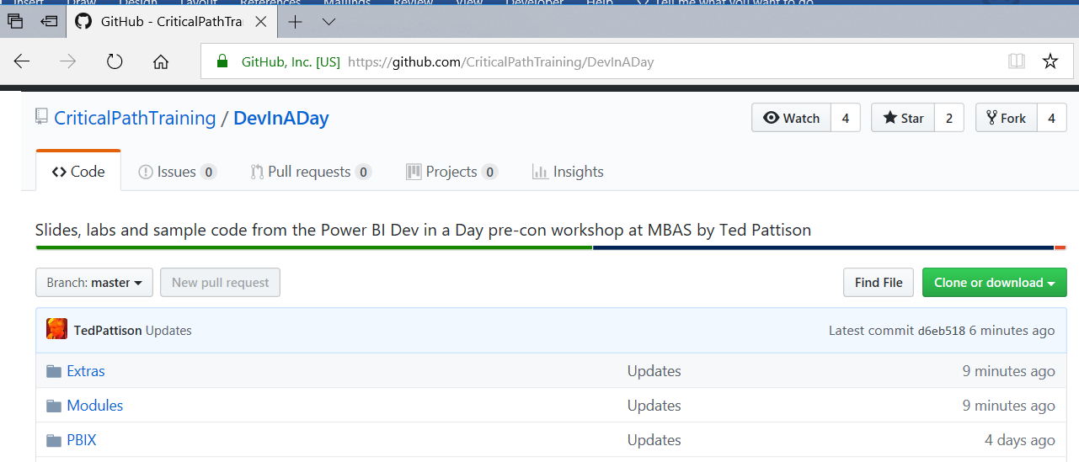

Note that [setup.pdf](https://github.com/CriticalPathTraining/DevInADay/raw/master/Setup.docx) is the setup guide used to configure your student PC and install the software you need to complete lab exercises. This exercise assumes that GIT has already been installed on your PC as discussed in the setup guide.

1. Copy the URL to clone the repository to the Windows clipboard.
   1. On the home page of the **DevInADay** repository, click the green **Clone or download** dropdown menu.
   2. Click the **Copy to clipboard** button to copy the URL to the Widows clipboard.

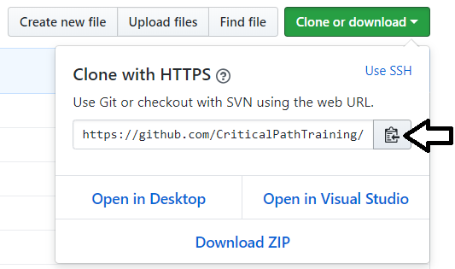

1. Use GIT to clone the **DevInADay** repository.
   1. Open up a Windows PowerShell command prompt.
   2. Type in and execute the following **git** command to download the student files to a local folder named **C:\Student**. Note that you copied the URL to github.com in the previous step and you can paste it from the Windows clipboard instead of typing it it.

git clone https://github.com/CriticalPathTraining/DevInADay.git C:\Student

* 1. When the **git clone** command runs, it will create a local copy of the repository on your local machine in the **C:\Student** folder.

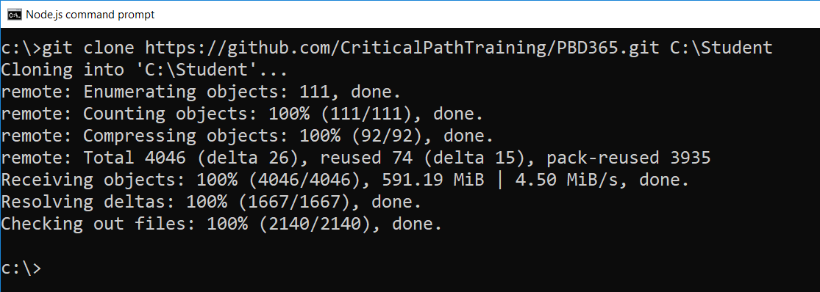

* 1. When the **git clone** command completes, open Windows Explorer and examine the **Student** folder. You should be able to see the **Student** folder has child folders named **Extras**, **Modules**, **PBIX** and **Scripts**.

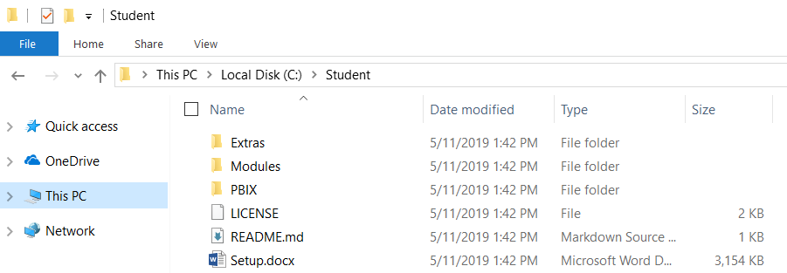

* 1. Drill into the **Modules** folder and look in the folder inside named **01_GettingStarted**.

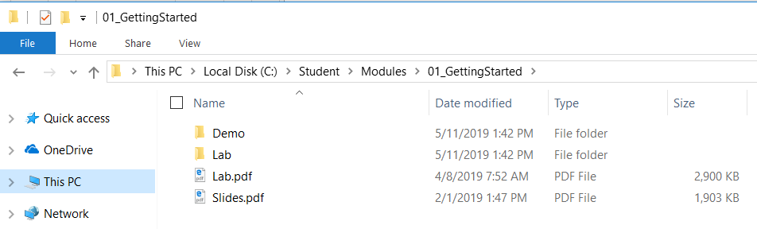

You can see that the **01_GettingStarted** folder contains folders named **Demo** and **Lab** as well as **Lab.pdf** and **Slides.pdf**.

### Exercise 2: Create an Office 365 Trial Tenant

In this exercise you will create a new Office 365 trial tenant. As you work through the sign up process for this free trial, you will be asked to provide a user name and a password for an Azure AD user account that will be configured as the tenant Global administrator. You will log in with this account when developing and testing applications that use Power BI embedding. However, it's a good practice that you also test your applications with standard user Azure AD accounts that have no administrative permissions. The trial tenant that you are going to create will allow you to create up to 25 user accounts with Office 365 E5 subscriptions. Remember that any user with an Office 365 E5 subscription is automatically assigned a Power BI Pro license as well.

1. Navigate to the Office 365 trial sign up page using an Incognito browser window.
   1. Launch the Chrome browser.
   2. Using the dropdown menu in the upper right, select the command to open a **New incognito window**.
   3. Copy and paste the following URL into the address bar of the incognito window to navigate to the signup page.

<https://go.microsoft.com/fwlink/p/?LinkID=698279&culture=en-US&country=US>

It’s not always necessary to sign up for an Office 365 trial account using an incognito window. However, most errors that occur when attempting to sign up for a new trial account are caused by user-specific browser settings such as cached credentials from another Office 365 account. The solution to overcoming errors when signing up for an Office 365 trial account is using an incognito window.

1. Fill out the form with your personal information and click **Next**.

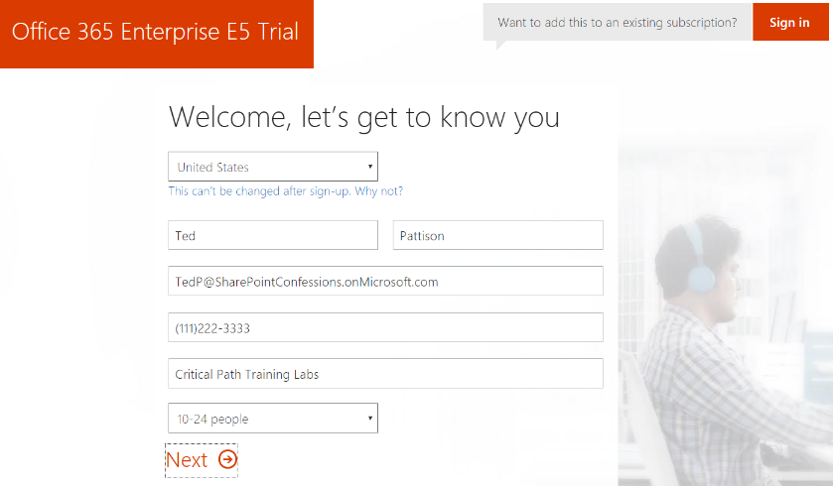

The information you provide on the next page of the signup process will be used to name your new Office 365 tenant.

1. On the **Create your user ID** page…
   1. Enter a user name
   2. Enter a unique company name *(you might have to try a few before you get one that’s unique)*
   3. Enter a password that you will remember.

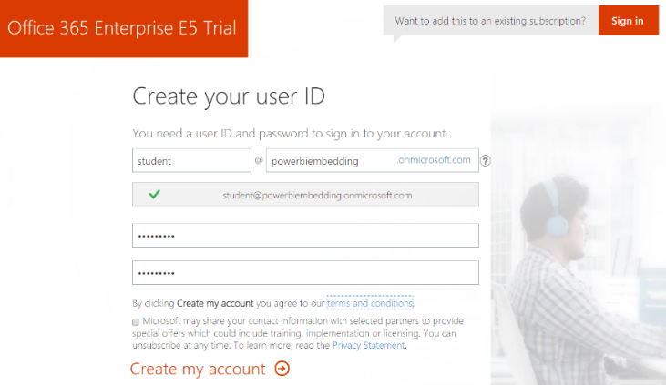

Note that the company name you enter on this page will be used to create the domain name for your new Office 365 trial tenant. For example, if you were to enter a company name of **powerbiembedding**, it would result in the creation of a new Office 365 tenant within a domain of **powerbiembedding.onMicrosoft.com**. The user name you enter will be used to create the first user account which will be given administrative rights within the Azure AD tenant. If you enter a user name of **Student**, then the email address as well as user principal name for this account will be **student@powerbiembedding.onMicrosoft.com**.

1. Click **Next** to continue to step 3.
2. Complete the validation form in step 3 by proving you are not a robot.
   1. Select the **Text me** option and provide the number of your mobile phone.
   2. When you go through this process, a Microsoft service will send you a text message that contains an access code.
   3. Retrieve the access code form your mobile device and use it to complete the validation process.



1. Once you have completed the validation process, click the **You’re ready to go…** link to navigate to the portal welcome page for your new Office 365 trial tenant. Note that you should already be logged on using the user account that was created during the signup process.

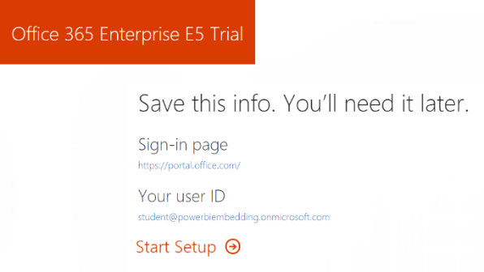

1. Click the **Admin button** to navigate the Microsoft 365 Admin center at **https://admin.microsoft.com/AdminPortal**.

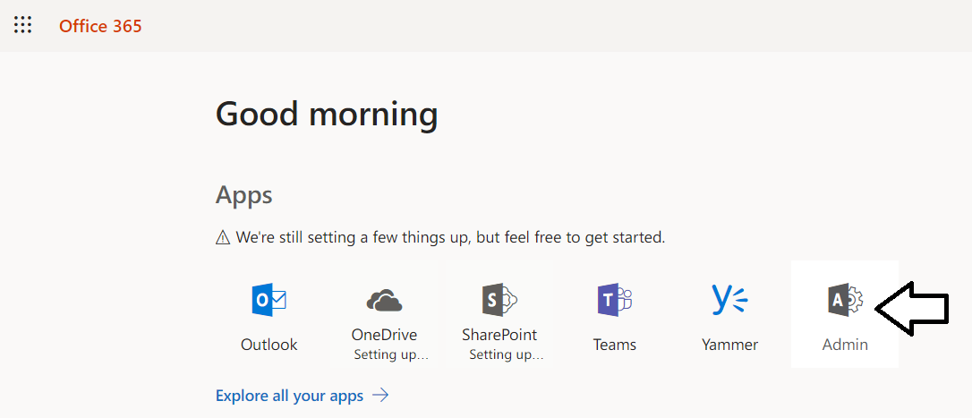

At this point, you have already created your new Azure AD tenant which can support creating up to 25 user accounts with Office 365 Enterprise E5 trial licenses. Note that some Office 365 services within your new Office 365 tenant such as the Microsoft 365 admin center, PowerApps, Flow and Power BI can be accessed immediately. Other services in your Office 365 tenant such as SharePoint Online, OneDrive for Business and Outlook will not be ready immediately and can take some time to provision.

There is no more need to run the browser in incognito mode anymore because it’s only required to get through the signup process. You can now return to using a standard browser window. However, it’s always a good thing to check to see who you are logged in as because sometimes the browser may log you on using a different Office 365 account you have instead of your new trial account.

1. At this point, you should be located at the **Microsoft 365 admin center** at **https://admin.microsoft.com/AdminPortal**.

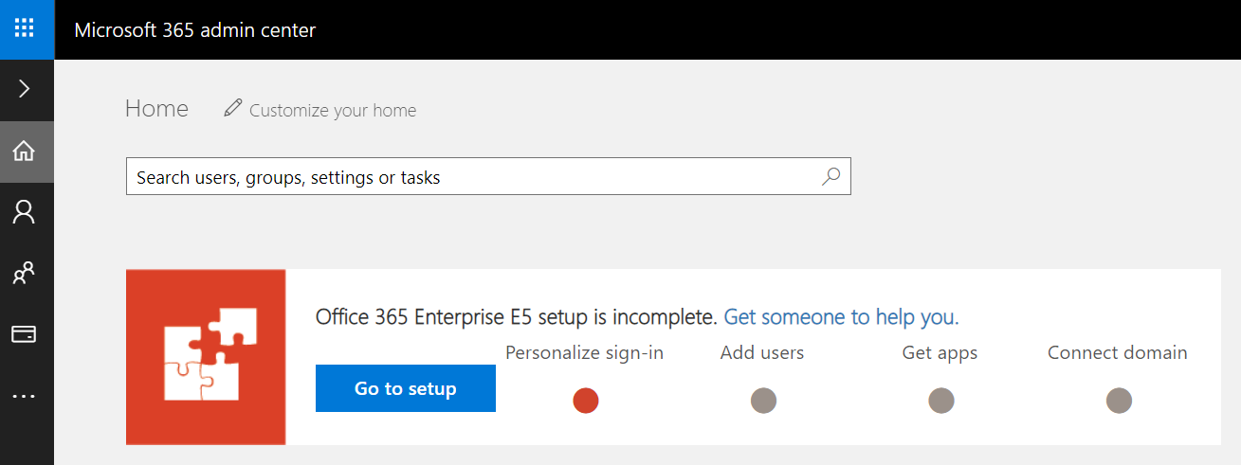

1. Inspect the set of Active Users in the current Azure AD tenant.
   1. Locate the top **Menu** button for the left navigation menu. It’s the second button from the top with the arrow icon which sits just beneath the Office 365 App Launcher menu button.

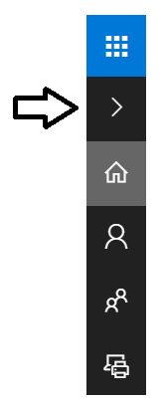

* 1. Click the top **Menu** button several times and see how it toggles the left navigation between a collapsed and expanded mode.

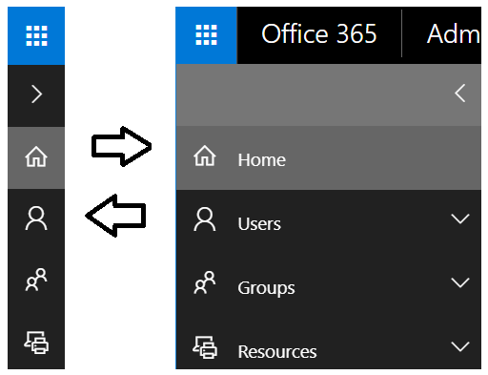

* 1. Once the **Active Users** page is displayed, you should be able to verify that the user account you are currently logged on as is the only user account that exists in the current tenant. Remember that this account has been set up as a Global Administrator to the tenant because it is the account that was created when provisioning your Azure AD tenant.

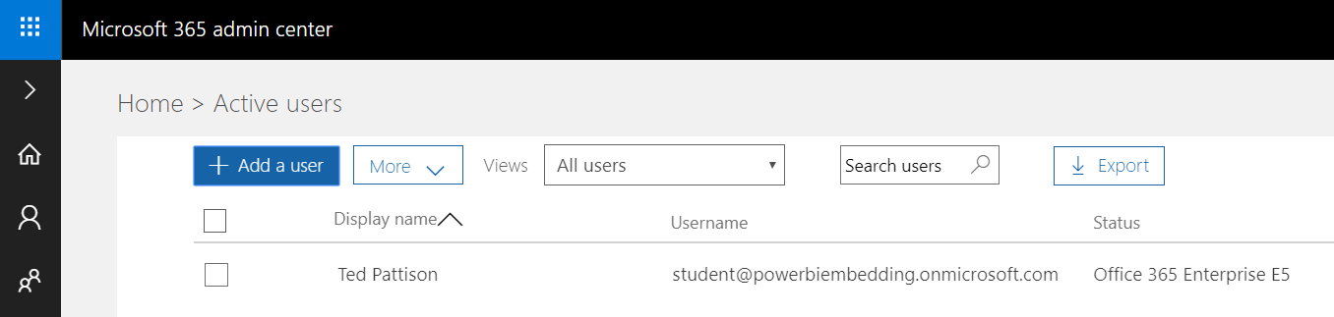

1. Create a new user account.
   1. On the **Active Users** page, click the button **Add a user** button to create a new user account

. 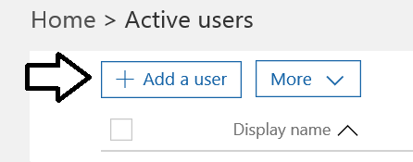

* 1. Fill in the **Create new user account** form with information for a new user account. When creating this account, you can use any name you would like. These lab instructions will demonstrate this by creating a user account for a person named **James Bond** with a user name and email of **JamesB@powerbiembedding.onmicrosoft.com**.

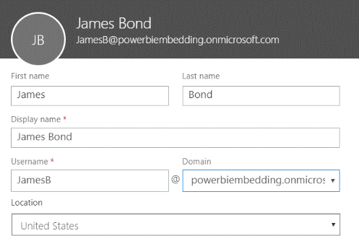

* 1. Expand **Password** section under **Contact Information** section.
     1. Select the option for **Let me create the password**.
     2. Enter a password of **pass@word1** into the textboxes labeled **Password** and **Retype** **Password**.
     3. Uncheck the checkbox for the option labeled **Make this user change their password when they first sign in**.

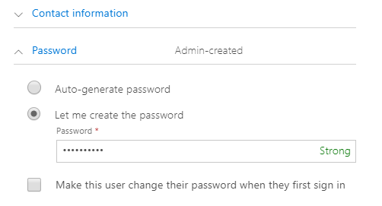

* 1. Expand the roles section. You do not need to change anything in this section, although you should note that this new user account will be created as a standard user account without any administrator access or privileges.

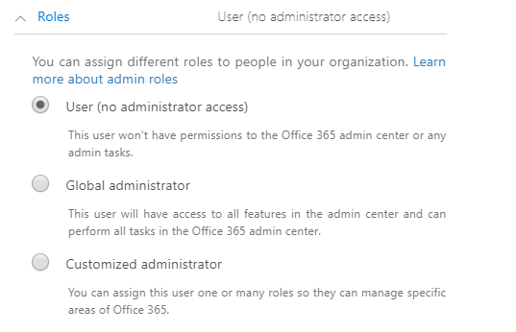

Note that the new account is usually assigned a trial license for **Office 365 Enterprise E5** plan. However, it’s a good practice to check and make sure the new user has been assigned a license for **Office 365 Enterprise E5** which includes the **Power BI Pro** license.

* 1. In the **Product licenses** section, make sure the **Office 365 Enterprise E5** license is set to **On**..

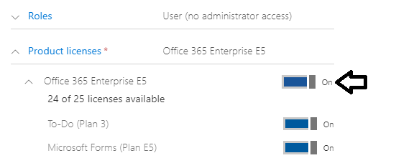

* 1. Click the **Save** button at the bottom of the new user form to create the new user account.
  2. When you see the **User was added** message, click **Send email and close** to dismiss the **Add new user** task pane.
  3. Verify that the new user account has been created and is displayed along with your primary user account.

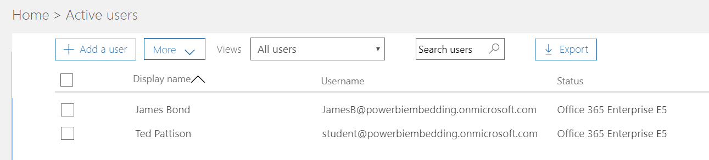

Now you have a secondary user account that does not have any administrative permissions. It's important that you test applications which use first-party embedding with standard user accounts to ensure your application doesn't require users with special permissions.

### Exercise 3: Create New Azure AD User Accounts using a PowerShell Script

Now that you have created an Azure AD user account by hand in the Azure portal, it's time to see how to automate this task using PowerShell. In this exercise, you will use the **AzureAD** PowerShell module to verify connectivity to your Office 365 tenant and to create a few new user accounts in your new Azure AD tenant. This lab assume you have already installed the **AzureAD** PowerShell module as described in the [setup document](https://github.com/CriticalPathTraining/DPBIE/raw/master/Setup.pdf) for this course.

1. Open and review the PowerShell script named **CreateUserAccountsFromCSV.ps1**.
   1. Using Windows Explorer, open the folder at the following location.

C:\Student\Modules\01_GettingStarted\Lab\CreateUsersScript

* 1. You should see several files including **UserData.csv** and **CreateUserAccountsFromCSV.ps1**.

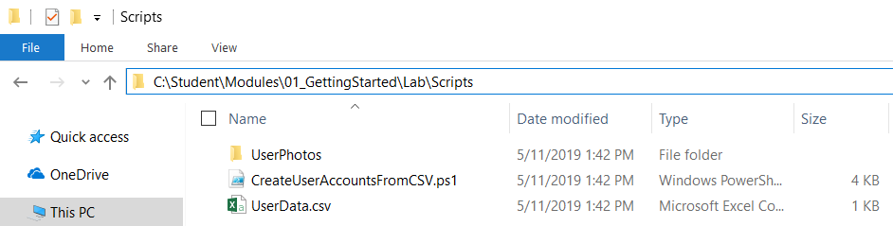

* 1. Open **UserData.csv** file in Notepad and examine the data inside which is formatted in a CSV format.

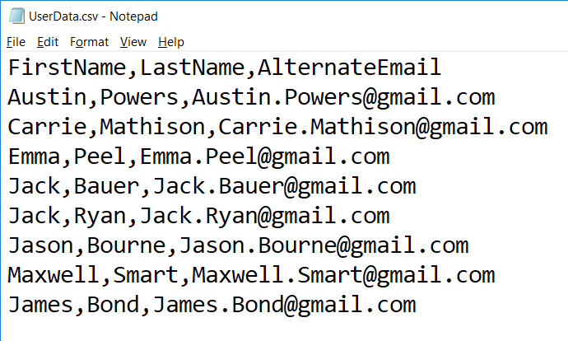

* 1. Close **UserData.csv** without saving any changes.
  2. Right click on the file named **CreateUserAccountsFromCSV.ps1** and click Edit to open the file in the PowerShell ISE.

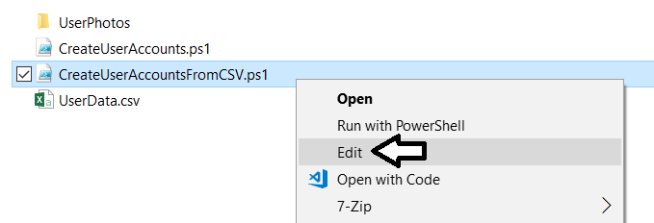

* 1. Take a moment to walk through the code in this PowerShell script.

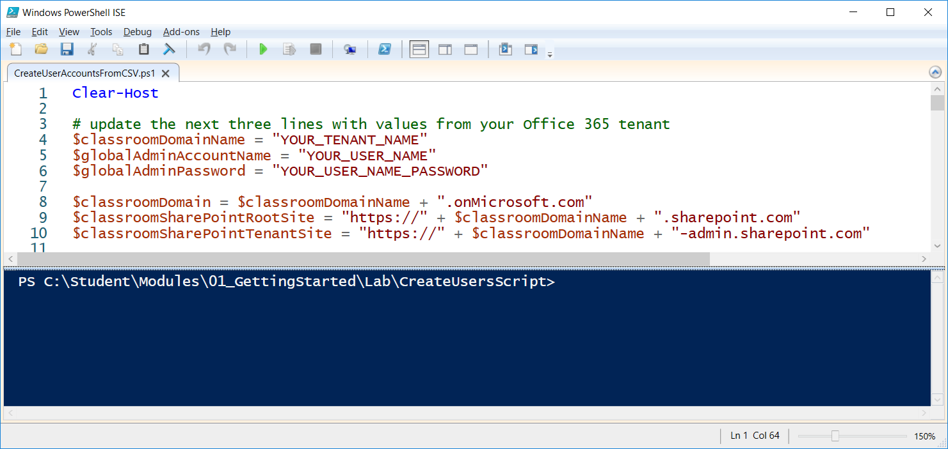

* 1. As you can see, the script creates new Azure AD user accounts using the **New-AzureADUser** cmdlet.

$password = "pass@word1"

$passwordProfile = New-Object -TypeName Microsoft.Open.AzureAD.Model.PasswordProfile

$passwordProfile.Password = $password

$passwordProfile.EnforceChangePasswordPolicy = $false

$passwordProfile.ForceChangePasswordNextLogin = $false

# Create new user account

$newUser = New-AzureADUser `

-DisplayName $displayName `

-GivenName $firstName `

-Surname $lastName `

-MailNickName $mailNickname `

-PasswordProfile $passwordProfile `

-PasswordPolicies "DisablePasswordExpiration, DisableStrongPassword" `

-UserPrincipalName $userPrincipalName `

-UsageLocation "US" `

-AccountEnabled $True

Note that any user account created with this script will have a password of **pass@word1**.

* 1. Move to the top of the script and edit the script to include the details for your tenant name, user account and password.

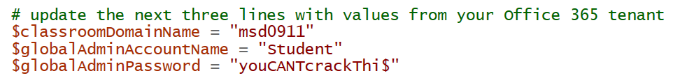

* 1. Save your changes to **CreateUserAccountsFromCSV.ps1**.

In the next step you will execute the PowerShell script which means you must have the ability to run PowerShell scripts on your Windows PC. If you are not able to run PowerShell scripts, you might need to open a PowerShell prompt as Administrator and then execute the **Set-ExecutionPolicy Bypass** command.

1. Run the PowerShell script named **CreateUserAccountsFromCSV.ps1** to create new user accounts in your new AD tenant.
   1. Inside the Windows PowerShell ISE, click the green arrow button on the toolbar to execute the script.

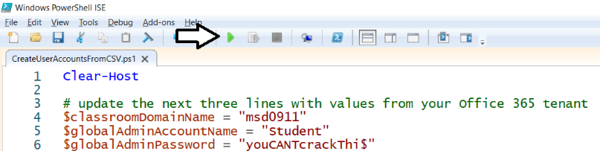

* 1. Once the script executes, return to the **Active users** view in Office 365 admin center and refresh the page to verify the new Azure AD user accounts have been created.

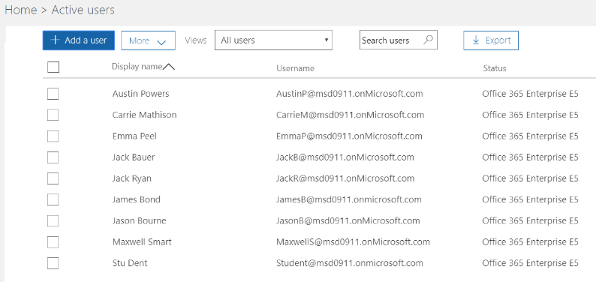

Note, there are user photos in the folder at **C:\Student\Modules\01_GettingStarted\Lab\CreateUsersScript\UserPhotos** if you want to upload photos for each of these users. Uploading user photos is not required so we leave this as an optional exercise for the reader.

### Exercise 4: Create New App Workspaces for a Custom Solution

In this exercise, you will create a new app workspace so you have a place to publish Power BI content for your custom solutions.

1. Navigate the Power BI portal at <https://app.powerbi.com>.
   1. If prompted, log in using your primary Office 365 user account.
2. Create a new app workspace named **Wingtip Sales**.
   1. Click the **Workspace** flyout menu in the left navigation.

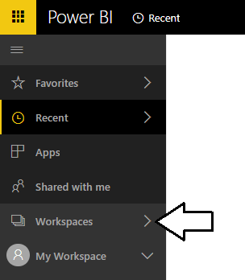

* 1. Click the **Create app workspace** button to display the **Create an app workspace** dialog.

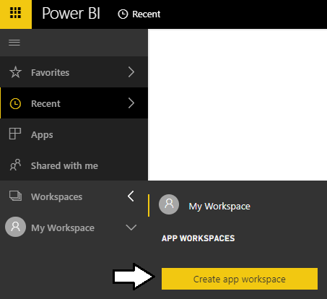

* 1. In the **Create an app workspace** pane, enter a workspace name of **Wingtip Sales**.
  2. Click the **Save** button to create the new group workspace named **Wingtip Sales**.

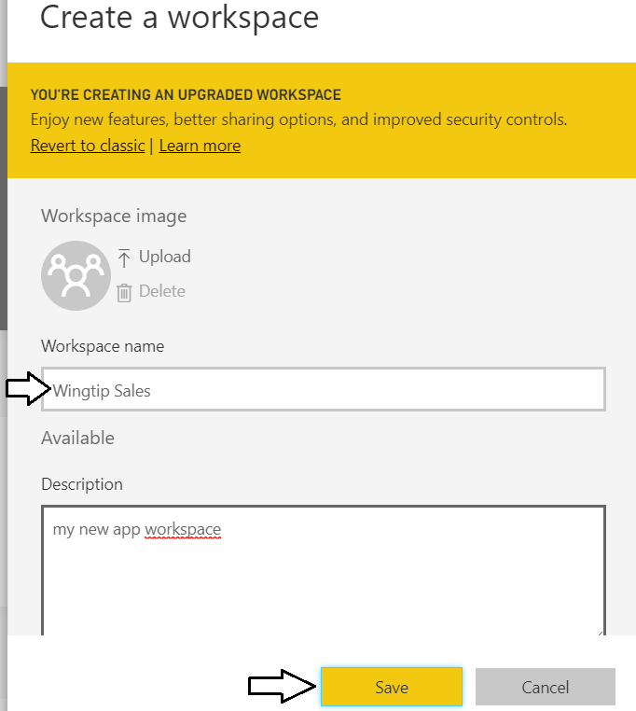

* 1. When you click **Save**, the Power BI service should create the new app workspace and then switch your current Power BI session to be running within the context of this new app workspace.

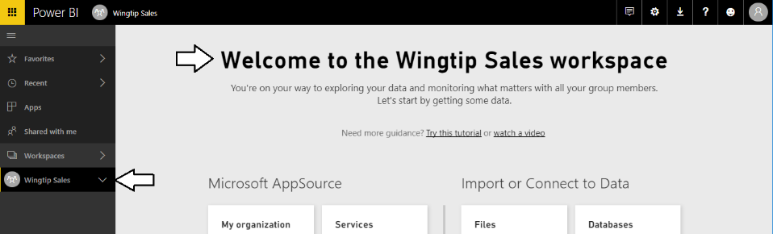

Now you have created an app workspace which provides the foundation for publishing and managing the Power BI dashboards, reports and datasets used by a custom solution.

### Exercise 5: Publish a Power BI Desktop Project to the Wingtip Sales App Workspace

In this exercise, you add content to the **Wingtip Sales** workspace by uploading the PBIX file named **Wingtip Sales Analysis.pbix**.

1. Navigate to the **Wingtip Sales** app workspace that you created in the previous exercise. This workspace should currently display the standard Welcome page because it does not yet contain any datasets, reports or dashboards.

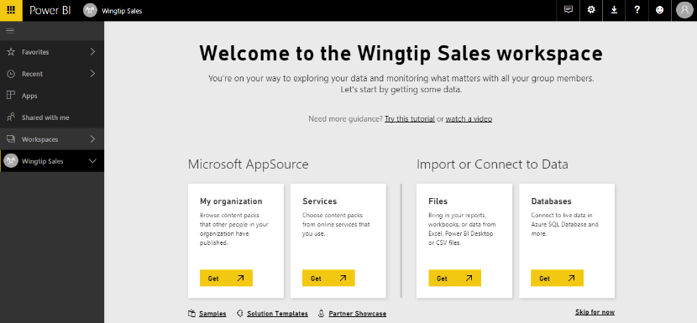

1. Import the **Wingtip Sales Analysis.pbix** project into the **Wingtip Sales** app workspace.
   1. On the Welcome page, click the **Get** button in the **Files** section.

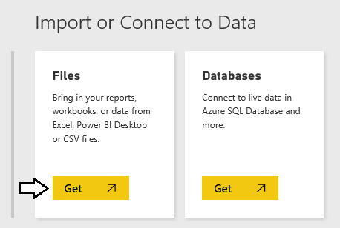

* 1. On the **Get Data > Files** page, click the **Local File** button to display the Windows **Open** file dialog.

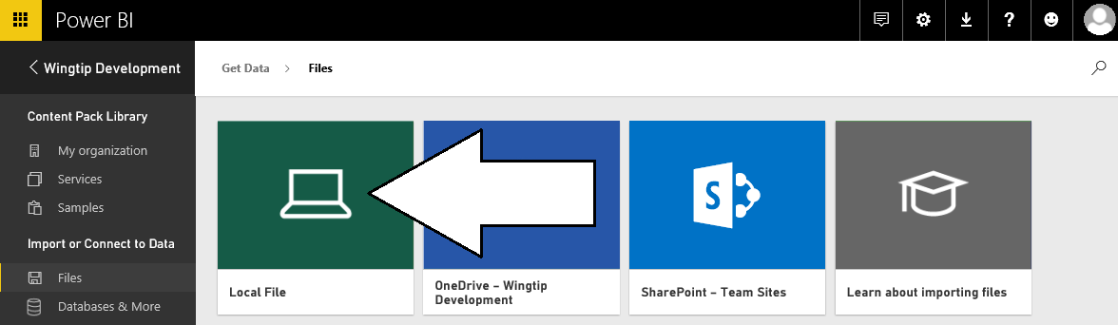

* 1. In the Windows **Open** file dialog, select the project file at **c:\Student\PBIX\Wingtip Sales Analysis.pbix** and click **Open**.

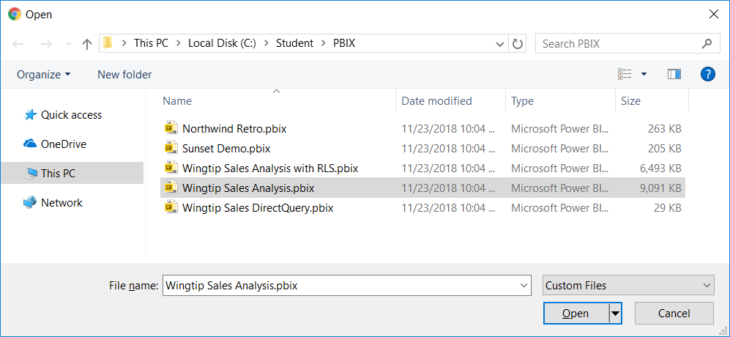

* 1. Wait while the Power BI service uploads the PBIX files and imports its assets into the **Wingtip Sales** app workspace

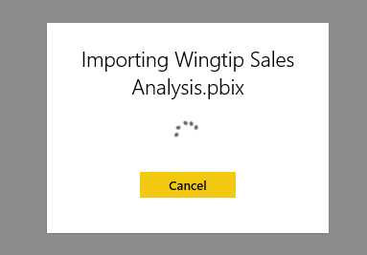

* 1. Once the import process completes, you should see a new dataset and a a new report in the left nav menu.

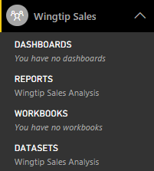

1. Click on the report named **Wingtip Sales Analysis** in the **Reports** section. Examine the pages in the report.

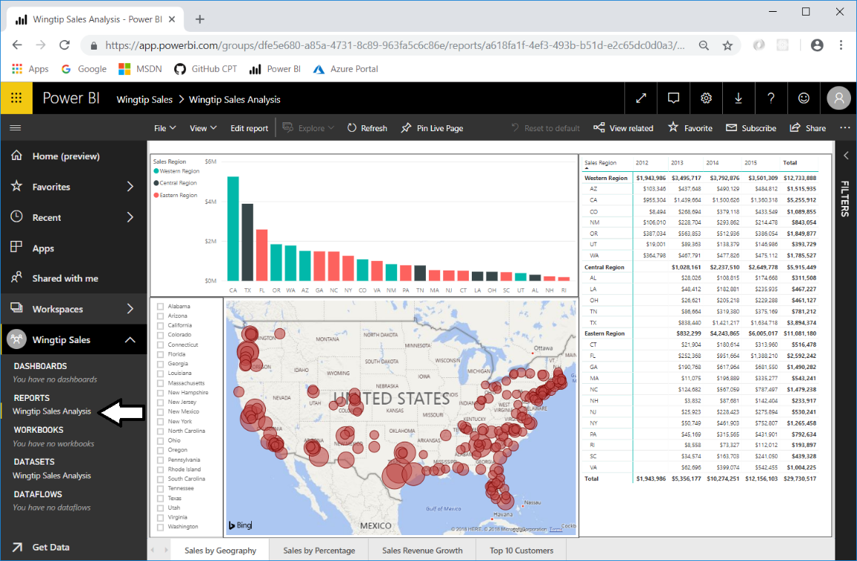

1. Click on each of the page tabs at the bottom of the report to inspect each page of this report,



1. In the left navigation, click on the dataset named **Wingtip Sales Analysis** in the **Datasets** section. The Power BI service responds by displaying a new report that allows you to begin adding visuals.

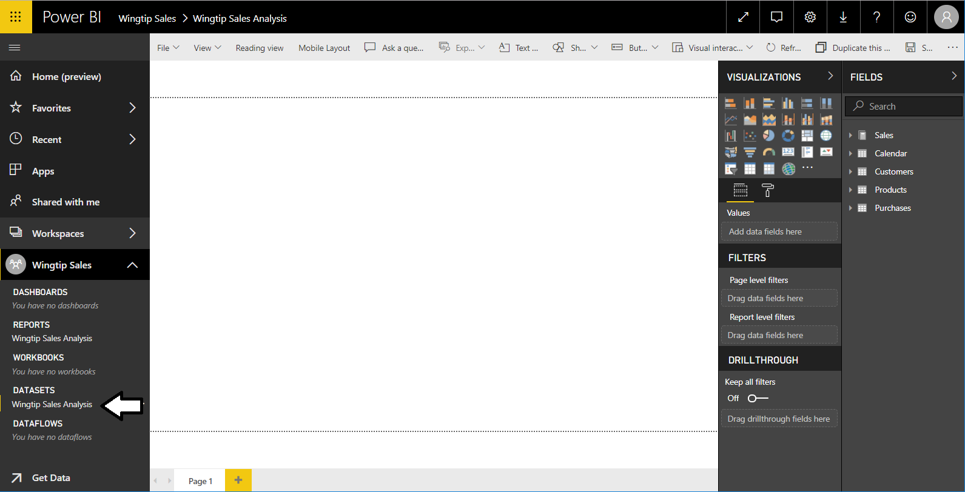

When you navigate to a dataset in the Power BI service, it provides a different experience compared to when in Power BI Desktop. That’s because Power BI Desktop allows you to customize and extend a dataset while the browser-based experience of the Power BI Service only allows you to consume datasets but not to modify them. Given the fact that a dataset is a read-only object, the Power BI Service responds to user’s request to navigate to a dataset by opening a new report and showing the **Fields** list for that dataset.

### Exercise 6: Create and Design the Product Sales Dashboard

In this exercise you will create a new dashboard using the dataset and report you created in the **Wingtip Sale Analysis** project.

1. Create a new dashboard named **Wingtip Sales Analysis**.
   1. Navigate to the **Reports** tab and open the report named **Wingtip Sales Analysis**.
   2. Navigate to the **Sales by Geography** page of the **Wingtip Sales Analysis** report.

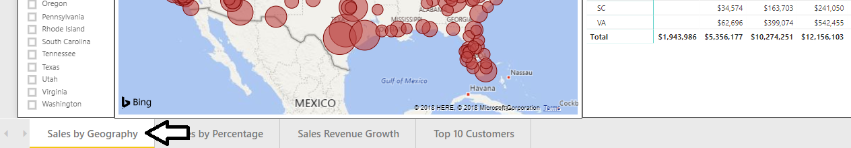

* 1. Hover the mouse over the column chart visual which displays a sales revenue breakdown across sales regions and states.

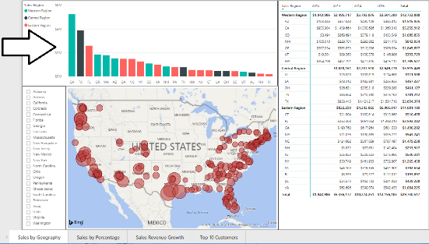

* 1. Locate and click the button with the thumbtack icon to pin this report visual to a new dashboard.

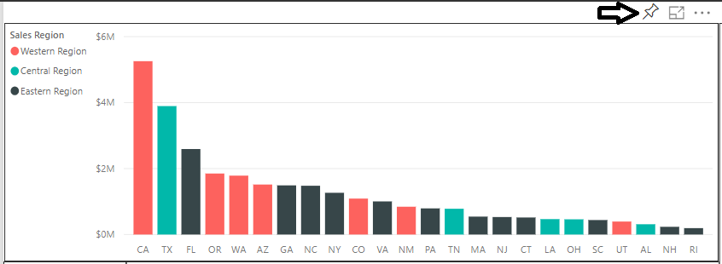

When you click the thumbtack button, you'll be prompted with the **Pin to dashboard** dialog which prompts you to select a dashboard.

* 1. Select **New Dashboard**, give it a name of **Wingtip Sales Analysis** and click the **Pin** button.

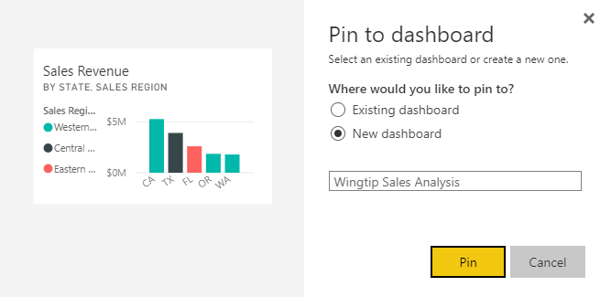

* 1. At this point, the **Wingtip Sales Analysis** dashboard should be created. Click on the link in the left navigation to display it.

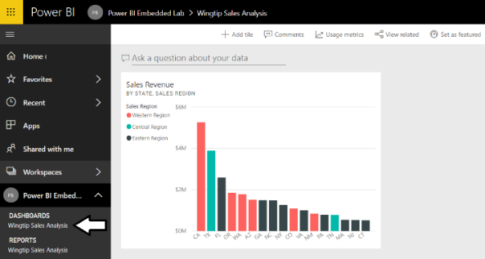

If you haven't previously worked with a Power BI dashboard, take a moment to experiment with resizing and moving the dashboard tile. Unlike a report, the changes you make to a dashboard tile are automatically saved without an explicit save action.

1. Remove the Q&A search box from the **Wingtip Sales Analysis** dashboard.
   1. You can see that the new dashboard is initially displayed with the Q&A search box in the upper left corner.

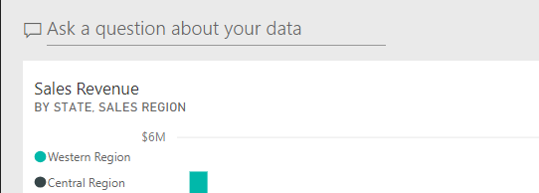

* 1. Click **Dashboards > SETTINGS** in the left navigation to display the **Settings for Wingtip Sales Analysis** pane.

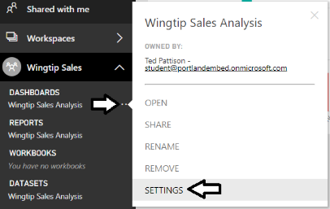

* 1. In the **Settings for Wingtip Sales Analysis** pane, uncheck the **Show the Q&A search box on this dashboard** checkbox.

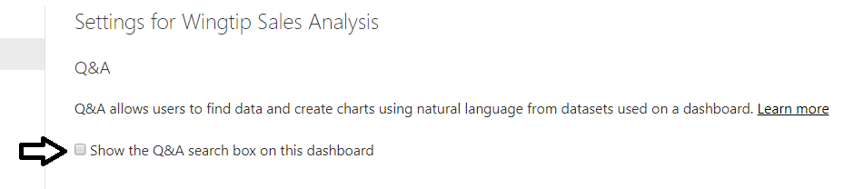

* 1. Click **Apply** below in the **Settings for Wingtip Sales Analysis** pane and confirm the Q&A search box is no longer showing.

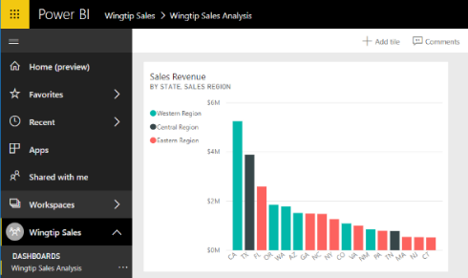

1. Add several more tiles to the dashboard by pinning visuals from the **Wingtip Sales Analysis** report.
   1. Repeat the process you used in step 1 to create the first dashboard tile to add additional tiles to the dashboard.

Choose whatever visuals you’d like from the **Wingtip Sales Analysis** report. However, you should make sure that your dashboard contains several tiles. Be creative and design a dashboard that looks better than the dashboards of the other students around you.

* 1. When you're done, your dashboard should look something like the dashboard in following screenshot.

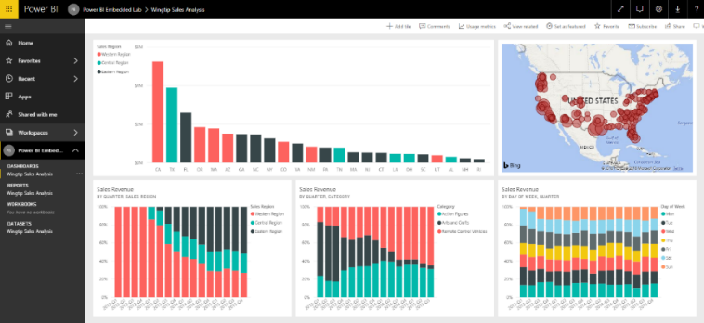.

### Exercise 7: Getting Started with Power BI Desktop

In this exercise, you will download and install the latest update of Power BI Desktop if you have not already done so. Then you will use Power BI Desktop to open and publish a pre-provided PBIX project file. If you already have the latest version of Power BI Desktop installed, you can skip over **Step 1** and begin with **Step 2**.

1. Install the latest update of Power BI Desktop (*if it is not already installed*).
   1. Using the browser, navigate to the landing page of the Power BI service at <https://app.powerbi.com>.
   2. On the top right of the Power BI service window, drop down the **Downloads** menu and click the **Power BI Desktop** menu command to begin the download of the installation file.

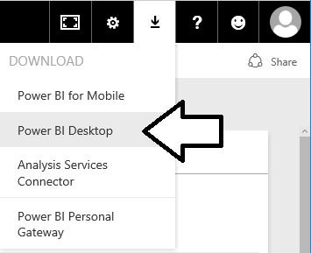

* 1. Wait for the MSI file to download.



* 1. Once the file has downloaded, click the **Run** button to begin the installation of Power BI Desktop.



* 1. When you see the Welcome screen, click **Next** to continue with the installation.

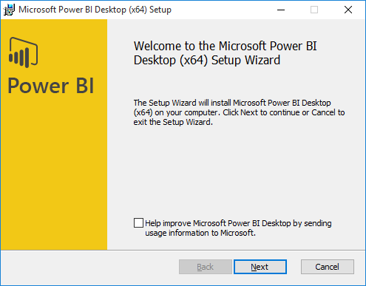

* 1. Click the checkbox to accept the license agreement and click **Next**.

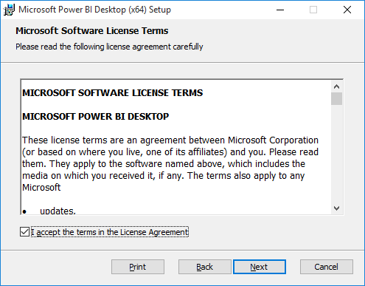

* 1. Accept the default location for the installation and click **Next**.

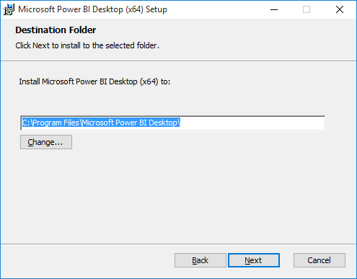

* 1. On the next screen, click **Install**.

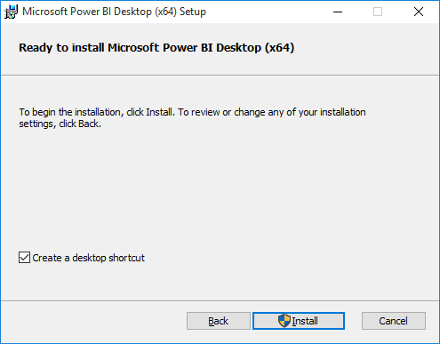

* 1. When you see the **Completed the Microsoft Power BI Desktop Setup Wizard** screen, click **Finish**.

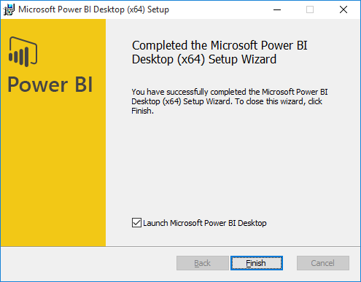

1. Launch Power BI Desktop.
   1. When Power BI Desktop launches for the first time, it displays a Welcome screen as shown in the following desktop. Click the (**X**) button in the upper right corner to close this window.

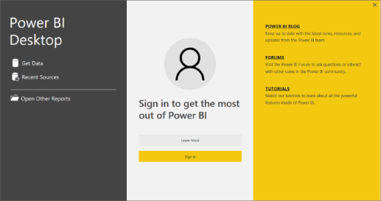

* 1. At this point, you should have Power BI Desktop running with a new, unsaved project as shown in the following screenshot.

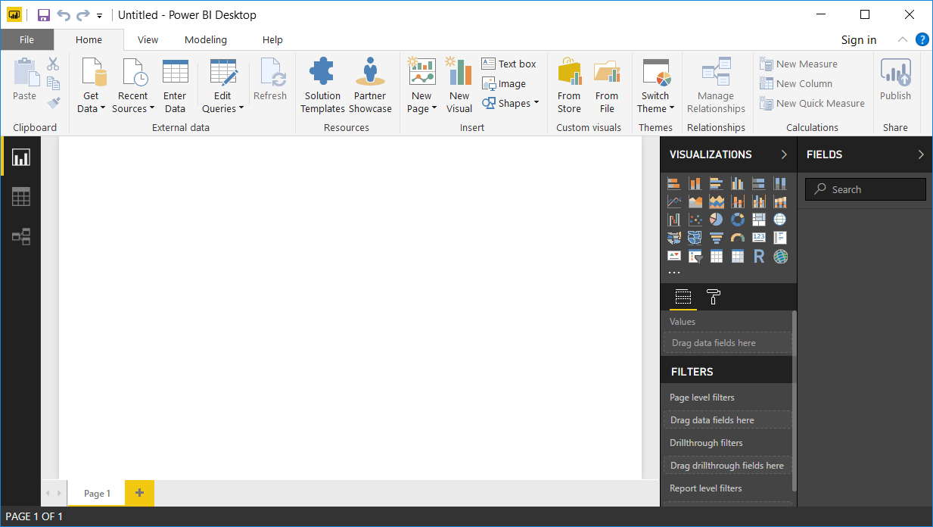

If you launch Power BI Desktop without logging into an organization account, you might be prompted by an obnoxious lead generation form which requires you to submit personal information to Microsoft in order to use the application. You can suppress this behavior of displaying the lead generation form by adding a Windows registry entry. There's a file named **DoNotShowLeadGenDialog.reg** which is located inside the **Student** folder at the path **C:\Student\Extras\DoNotShowLeadGenDialog.reg** to add the required registry entry.

1. Open the Power BI Desktop project file named **Wingtip Sales Analysis.pbix**.
   1. Select he **File > Open** command from within Power BI Desktop.

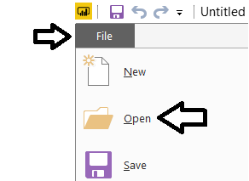

* 1. Locate the PBIX file located at the following path.
  2. In the Windows **Open** file dialog, select the project file at **c:\Student\PBIX\Wingtip Sales Analysis.pbix** and click **Open**.

c:\Student\PBIX\Wingtip Sales Analysis.pbix

* 1. Open **Wingtip Sales Analysis.pbix** to load this project into Power BI Desktop.



The project should now be open in Power BI desktop.

1. Inspect the contents of the Power BI Desktop project named **Wingtip Sales Analysis.pbix**.
   1. Inspect the report in the **Wingtip Sales Analysis** project. You should see if provides four pages.

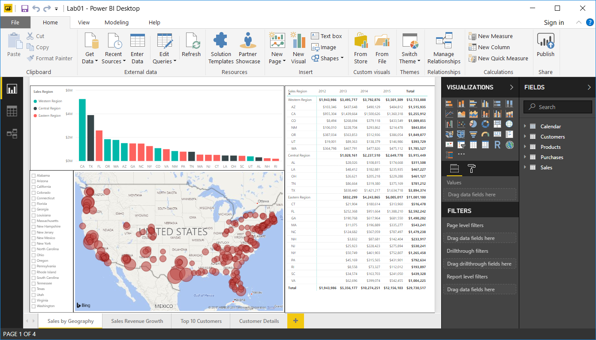

* 1. Using the navigation tabs at the bottom of the report, move from page to page to inspect each page in the report.

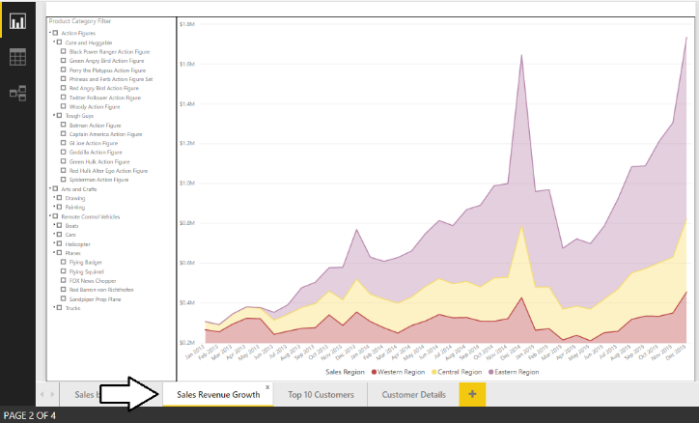

* 1. Click on the Relationship view button in the left navigation to see the tables included in data model and their relationships.

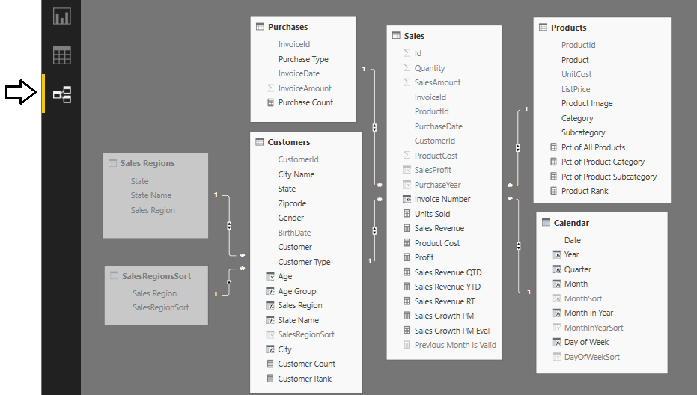

* 1. Click on the Data view button in the left navigation to see a tabular view of the data inside the project’s data model. Note that you can select a table in the FIELDS list on the right to see the data in that table.

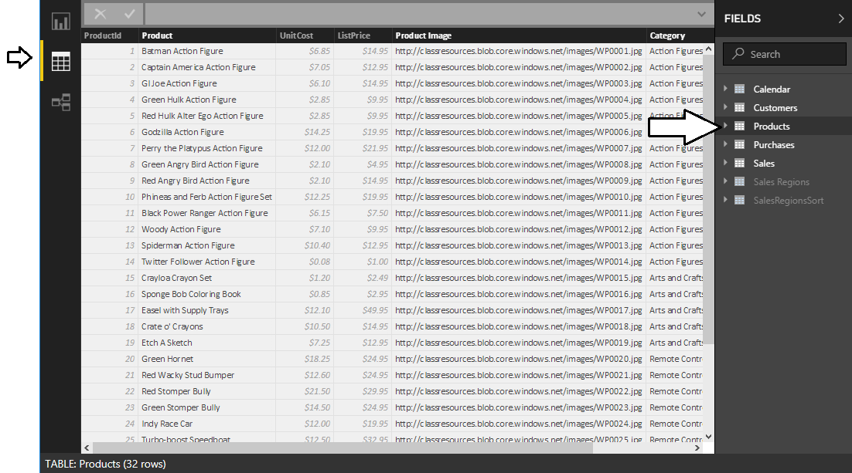

You do not need to make any changes to this Power BI Desktop project. The purpose of this lab is for you to open an existing project that has already been completed and then to publish it to the **Wingtip Sales** app workspace.

1. Publish the **Wingtip Sales Analysis.pbix** project to the Power BI Service.
   1. Navigate to the **Home** tab in the ribbon and click the **Publish** button on the far right-hand side.

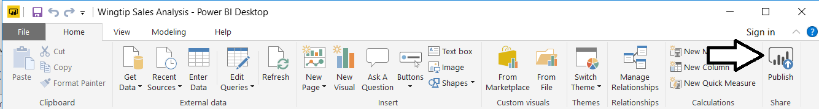

* 1. When promoted with the **Sign in to Power BI** dialog, click the **Sign In** button

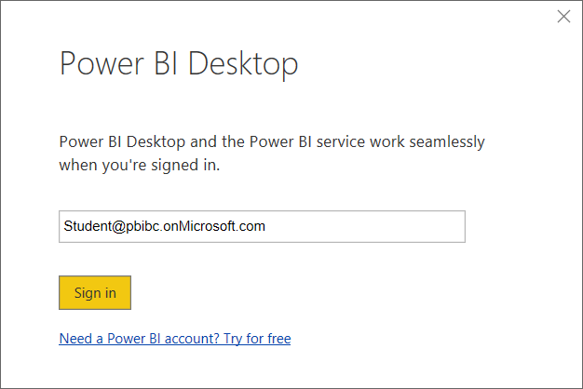

* 1. When prompted for your password, sign into the Power BI Service.
  2. When Power BI Desktop prompts you with the **Publish to Power BI** dialog, select **Wingtip Sales** and then click **Select**.

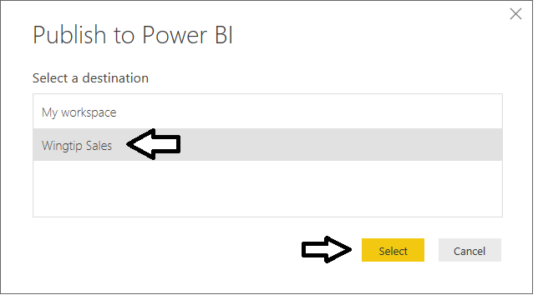

Since there is already a dataset named **Wingtip Sales Analysis** in the **Wingtip Sales** app workspace, you will be prompted with the **Replacing dataset** dialog to confirm you want to replace an existing dataset.

* 1. Click the **Replace** button in the **Replacing datasets** dialog to continue.

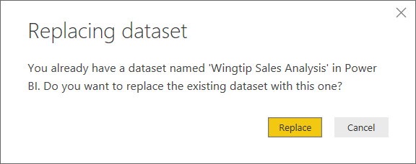

* 1. Power BI Desktop will display the **Publishing to Power BI** dialog as the publishing process begins.

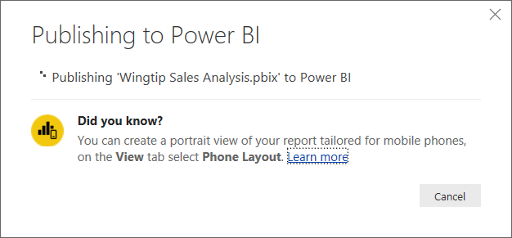

* 1. Once the publishing process has completed, the **Publishing to Power BI** dialog will display a success message and provide you with a link to **Open Wingtip Sales Analysis.pbix in Power BI**. Click on that link to navigate to the Power BI Service using the browser.

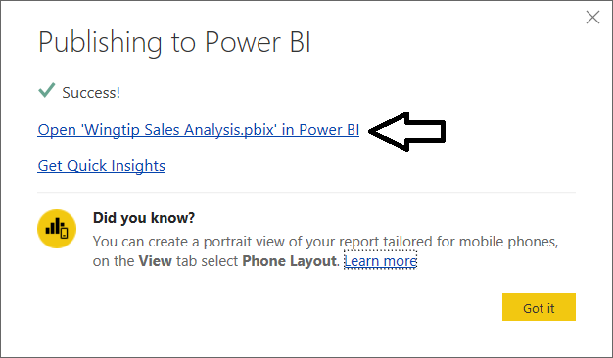

* 1. You should now be able to see the same report you published earlier.

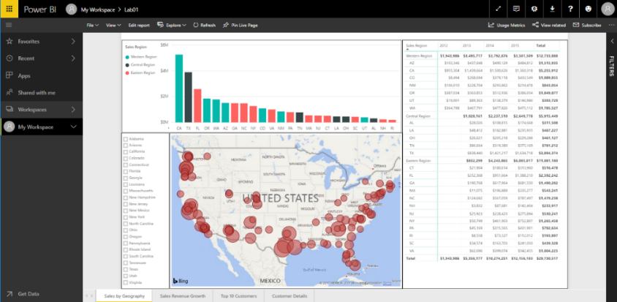

You have now successfully published a PBIX project using Power BI Desktop. But what happens when you want to make a change to a report after it has been published? It’s very easy because you can make changes to your Power BI Desktop project and republish it on top a previous version of the same project that has already been published.

1. Change the Default color property of the Map visual that displays sales revenue by month and purchase type.
   1. Return back to Power BI Desktop and make sure you are in report view for the project named **Wingtip Sales Analysis.pbix**.
   2. Return to the **Sales by Geography** page.
   3. Select the **Map** visual.

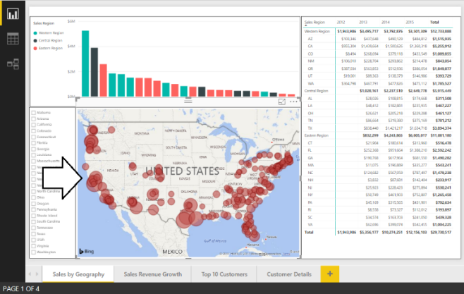

* 1. Update the **Default color** property in the **Data colors** section in the **Format pane** to change the color of the bubbles from red to a different color of your choice such as yellow or purple.

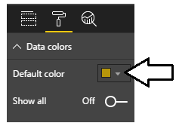

* 1. Verify that the bubbles in the Map visual are now a different color than red.

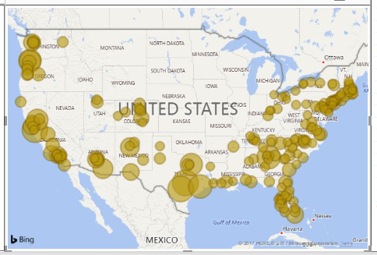

* 1. Save your changes to **Wingtip Sales Analysis.pbix**.

1. Republish the project to the Power BI service.
   1. Click the **Publish** button on the far right-hand side of the **Home** tab in the ribbon.
   2. When prompted with the **Publish to Power BI** dialog, select the **Wingtip Sales** app workspace and then click **Select**.
   3. When prompted with the **Replacing dataset** dialog, click **Replace** to begin the publishing process.
   4. Once the publishing process has completed, inspect the published report in the Power BI service using the browser. Verify that the bubble color within the Map visual has been updated.

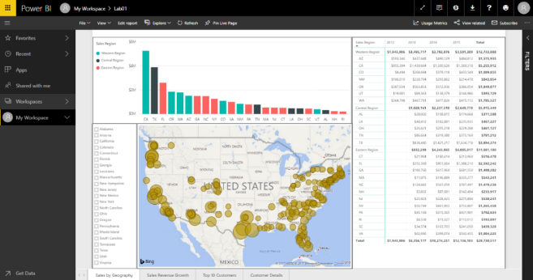

### Exercise 8: Use Publish to Web to Surface a Report on a Custom Web Page

In the final exercise of this lab, you will use the Power BI Publish to Web feature to display the **Wingtip Sales Analysis** report on a custom web page.

1. Locate and open the HTML file named **PublishToWeb.html** for editing.
   1. Using Windows Explorer, locate **PublishToWeb.html** in the **C:\Student\Modules\01_GettingStarted\Lab** folder.

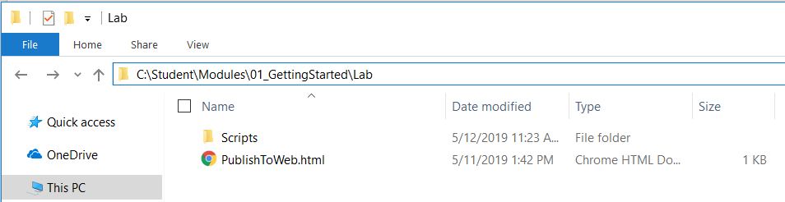

* 1. Open **PublishToWeb.html** in an text or HTML editor such as Visual Studio, Visual Studio Code or Notepad.
  2. Examine the HTML content inside **PublishToWeb.html**. and locate the **TODO** comment inside.

<!DOCTYPE html>

<html>

<head>

<meta charset="utf-8" />

<title>Lab 1</title>

</head>

<body>

<h2>Publish to Web</h2>

<div>

<!-- TODO: Embed Power BI Report Here-->

</div>

</body>

</html>

1. Use the Publish to Web feature to create an embed code and an embeddable iframe tag
   1. In the browser, return to the Power BI portal and the **Wingtip Sales** app workspace.
   2. Open the report named **Wingtip Sales Analysis**.

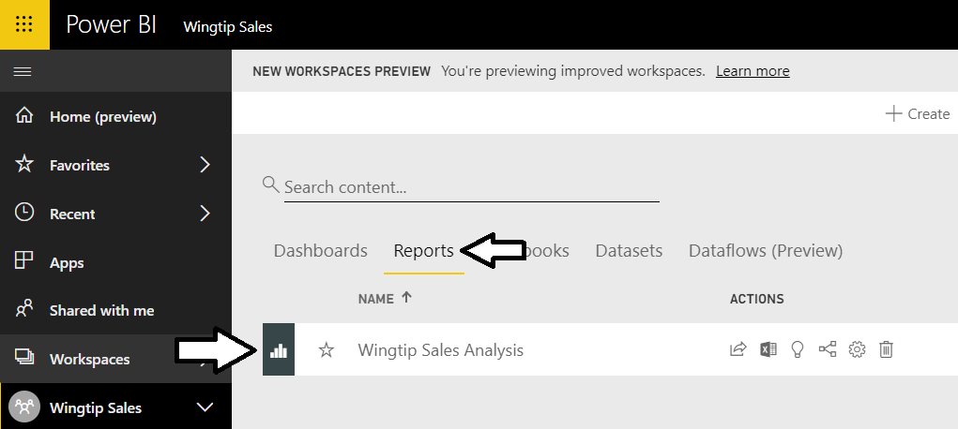

* 1. Drop down the report’s **File** menu and select the **Publish to Web** command.

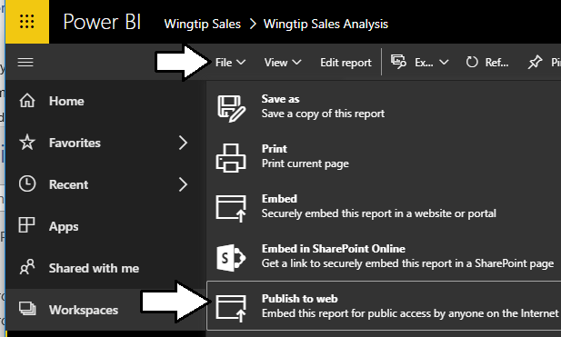

* 1. When prompted with the **Embed in a public website** dialog, click the **Create embed code** button.

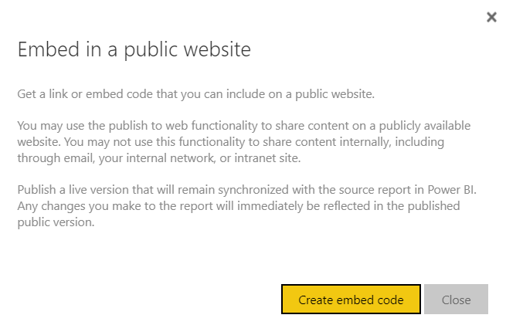

* 1. On the next page, click the **Publish** button.

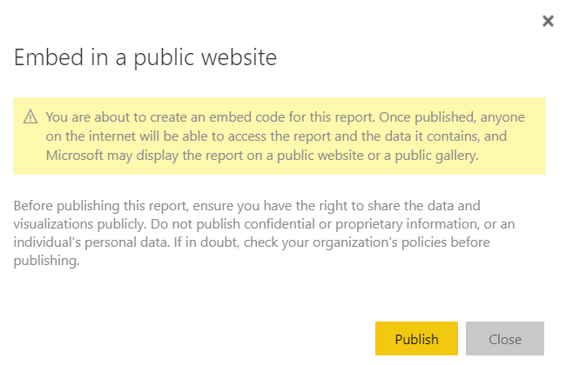

* 1. Inspect what is displayed to you on the **Success!** Page.

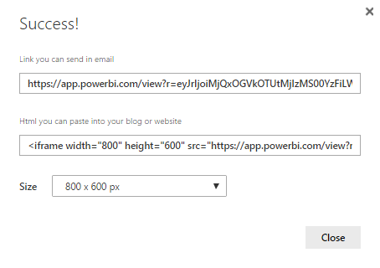

* 1. Select the contents of the **Html you can paste into your blog or website** textbox and copy it to the Windows clipboard,

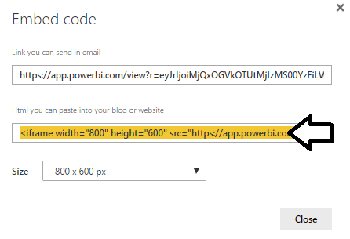

* 1. Return to **PublishToWeb.html** and paste the HTML snippet with the iframe tag just below the TODO comment.

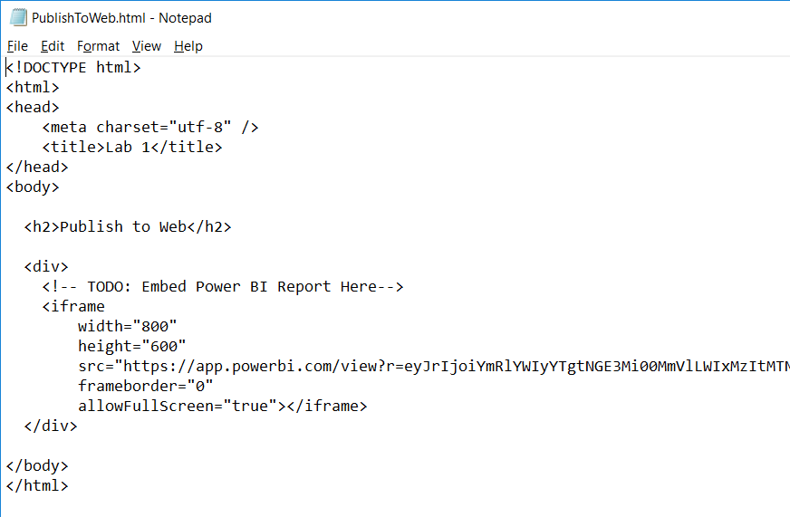

* 1. Update the **width** attribute of the iframe to **1024**.

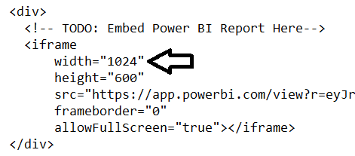

* 1. Save your changes to **PublishToWeb.html**.
  2. Using Windows Explorer, double-click on **PublishToWeb.html** to open this HTML file in a browser.
  3. You should see your report displayed in the custom web page.

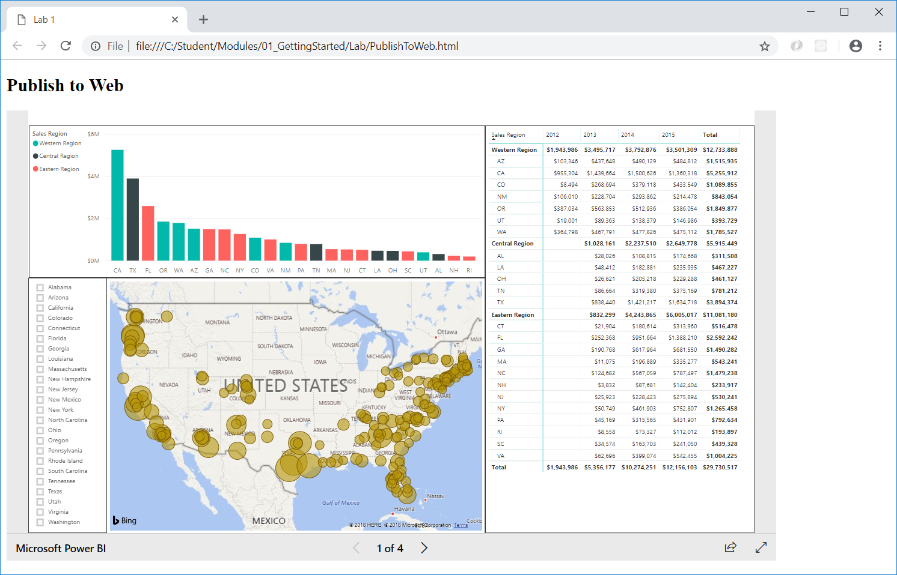

Remember that the Publish to Web feature is not secure and is only available via anonymous access. Developing with Power BI embedding will provide a secure and far more flexible way to surface reports and dashboards in a custom application.

Congratulations, you have now finished this lab.